**Biorefrigerator Security System**

Biomedical Engineering Senior Design

Dr. Aijun Wang

Progress Report 2

Winter 2024

Team 1

# 

**Problem and Objective 3**

**Problem 3**

**Objective 3**

**Concept Generation 4**

Concept Generation Flow Chart 4

Primary Design Concepts 5

**Concept Screening 8**

**Primary Screening 9**

**Secondary Screening 11**

**Materials and Manufacturability 12**

**Detail Drawings 13**

**Concept 1 13**

**Concept 3 14**

**Concept 2, Final Concept Chosen, Initial Design 15**

**References 15**

**Appendix 16**

# Problem and Objective

## **Problem**

Current methods of ensuring that frequently accessed controlled laboratory environments remain closed are limited by the need for human input. Requiring the use of human input introduces the possibility of human error. In the case of currently used controlled laboratory environments, the most likely error is unintentionally leaving open controlled laboratory environments. This error can result in significant risk to the viability of materials within them, such as the denaturing of DNA or cells in the controlled environments.

## 

## **Objective**

The objective of the Biorefrigerator Security System is to implement a device that minimizes the risk of sample deterioration due to prolonged exposure to ambient conditions. We aim for the device to be power efficient, affordable, easy to install, and easy to use. By both controlling and reporting the status of biological refrigerator doors, our device can be used by laboratory staff to autonomously close the doors.

Concept Generation

## Concept Generation Flow Chart

When we were looking and thinking about designing a device to help secure refrigerator doors, we started thinking about what should be considered in providing security and a way to keep the door closed or know when the door is open. We considered parts that could help with the device. The main two factors we considered were sensors and whether we should use digital components. We also realized that simple is better, as this would reduce the possibility of error. Our initial ideas only involved using the door, so therefore we decided to think about hinges. Overall, we realized that in order to decide what to design we should consider the best components to use and which to combine to provide the best concept to develop. By combining components and ideas that may cover for each other’s weaknesses, we could create a product that satisfies more of the criteria that we have set.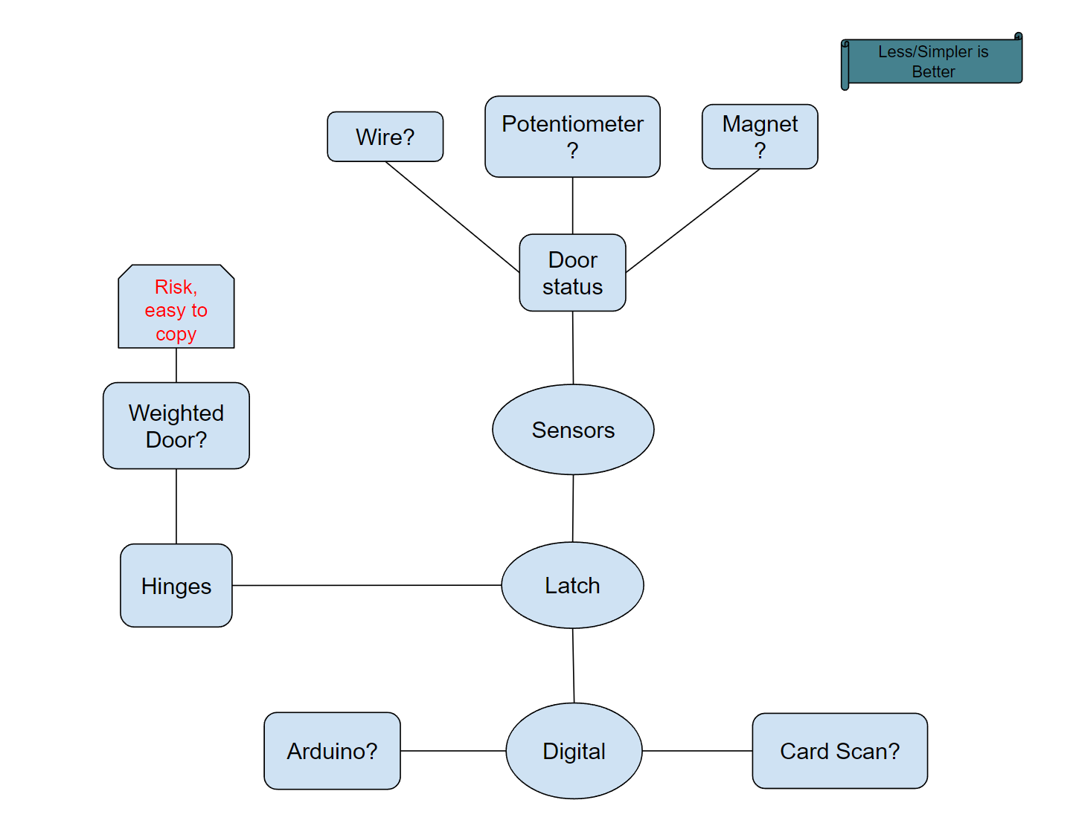

## **Primary Design Concepts**

When starting prototype ideas, when we looked back at our concept generation flow chart that we made, we realized that what we will prototype is based on many components that needed to be combined together. We realized that it would be good to make our first primary screening based on three components: detection, security, and alarm. We will have two primary screenings: Input, combining detection and security, and notification/alarm. Specific components we will screen are shown below and will have a description of why each component was considered.

| **Input(Status and Verification)** | |
| --- | --- |
| **Detection** | **Security** |
| Laser/Optical | Card |
| Magnetic | PinPad |
| Temperature | Finger Pad |
| Weighted |  |
| Wire |  |
| Angle Sensor |  |
| **Alarm/Notification** | |
| Digital | Light Flashing |
| Sound Alarm | No Alarm |

Component Section 1

All components listed below contribute to detection or remote signaling of door status..

**Laser** A laser sensor will help detect the open or closed status of the door by applying a laser to the door, which will constantly reflect back to a pad placed on the main part of the refrigerator. If the refrigerator door is open, then the laser will move with the door and leave the padding. Without the padding, reflection cannot occur and therefore the laser will detect that the door is open.

**Magnetic**  A magnetic sensor will have two separate magnets: one on the door and one on the main compartment. When the magnets are together, then the connected magnets will enable the sensor to detect when the door is open.

**Temperature** A temperature sensor will be placed on the inside of the refrigerator. If the temperature increases past a certain point, then the sensor will detect that the refrigerator has been left open for too long.

**Weighted**

A weighted door will actively close the refrigerator door if the door is left open. The weighted system will pull the door closed.

**Wire**

A wire will be set somewhere between the refrigerator door and main compartment. If the wire is pulled too long, then the sensor will know that the door is left open. The wire can also help with closing the door as it will retract.

**Angle Sensor**

An angle sensor can be placed at the hinge of the door and can detect whether the door is open or closed if the sensor detects a high angle.

Component Section 2

The following components below are based on factors of security in order to check who opens the door whether specifically tied or a person or just anyone who has the information to open the door.

**Card Reader**

Most labs in UC Davis have a magnetic card for each person who works in a lab. We can use a card with the refrigerator lock to tell who is opening the door since cards have tracking systems that can be traced back to the user of the card.

**PinPad**

Using a PinPad can allow people who only know the password enter or have everyone have their own passcodes to know who specifically opens the refrigerator door.

**Finger Pad**

A finger pad sensor can be used to access the door while knowing who specifically opened the door with fingerprint authentication.

The following components are based on alarms or notifications. This can be used when the detection component notices the door is left open:

**Digital**

A digital notification would send an alert to the phone or computer of the administrator of the lab from an application. This solution necessitates either an internet connection or bluetooth connection. An internet connection would be preferred since it could work regardless of distance.

**Sound Alarm**

A sound alarm on the device can alert those in the area that a refrigerator had been left open and that the samples inside are prone to denaturing or being compromised.

**Light Alarm**

A light alarm on the device can provide an easy visual alert for a user to see that the refrigerator has not been shut all the way in order for the user to prevent the samples from degrading due to the refrigerator being open for too long.

**No Alarm**

Having no notification system could be feasible with solutions that guarantee the door closing when left open. Furthermore, it requires no extra materials. This solution comes with the downside that, should the closing device malfunction, no one would know without manually checking.

# 

# 

# Concept Screening

## Primary Screening

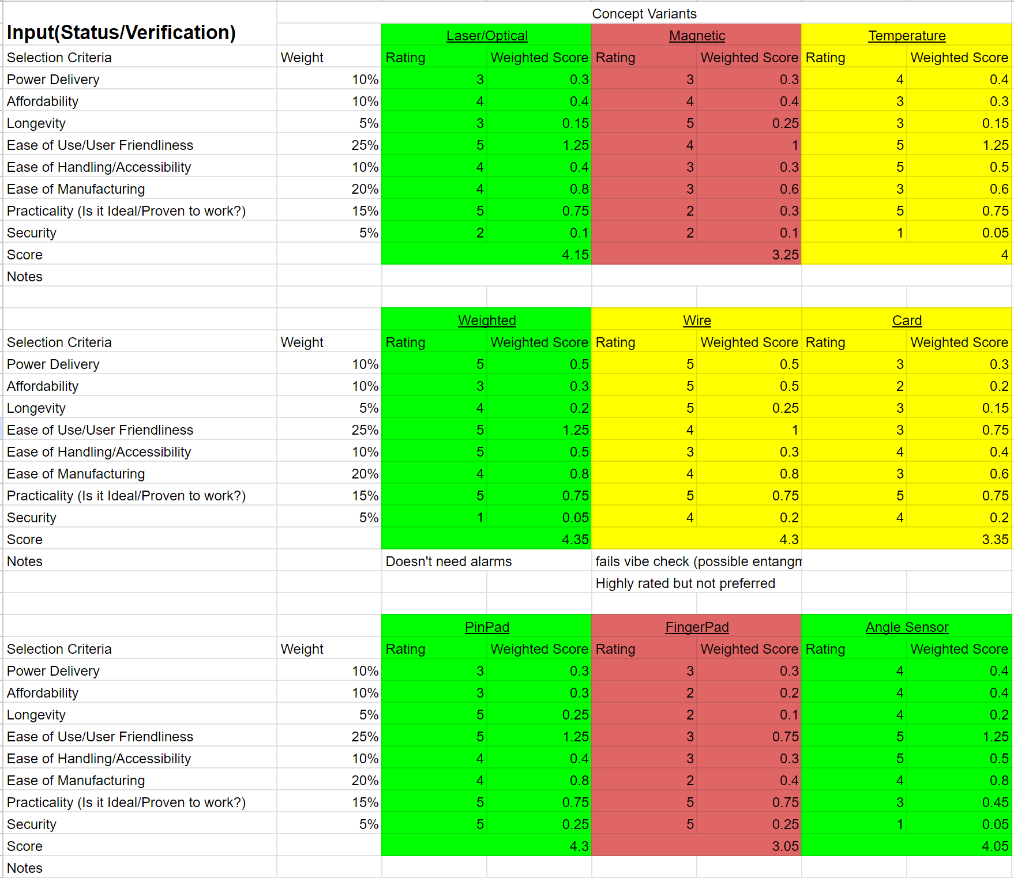

# 

Looking at the primary screening, we rated each component based on the following criteria: power delivery, affordability, longevity, ease of use/user friendliness, ease of handling/accessibility, ease of manufacturing, practicality, and security. Each of these comes from an updated version of the User Needs Flowchart. To clarify the differences between ease of use and ease of handling, ease of use is a customer's ability to quickly understand how to use the product while ease of handling is a customer’s ability to physically interact with the product. Practicality is to determine whether previously devices using the component were used well or well received. Security, while initially thought to be highly prioritized, has significantly less weight as security has been proven to be high through other means. Overall, the ease of use and ease of manufacturing was set to have the highest weight. We want the customer to be able to quickly understand our product and we want to have easy manufacturing in order to have quick prototyping and quick reiterations of the device.

We divided all components into different colors categories: red, yellow, and green. The red category means that the component is poorly rated. After checking and talking with the team, the red components were not considered to move on to the secondary screening. The yellow categories could have been well-rated overall, but they will not move on to the secondary screening after proper deliberations between team members. For example, the wire system was highly rated, but it still seemed very intruding and obstructive to people wanting to open the door no matter where we placed it since a wire system would end up being tough to untangle and maneuver, and therefore, was moved to the yellow category. Finally, the green components were selected based on their high rating as well as being well received between team members and therefore, moved onto the secondary screening. Green-rated systems indicate that they are not too difficult to manufacture, take up a reasonable amount of space, and are intuitive methods for the user to interface with. Note that we did not blindly select random green components for our secondary screening, but rather deliberated over which components would work best in the green category. Overall, we made 3 prototype ideas to be put for the secondary screening.

## **Secondary Screening**

For our secondary screening, we created 3 concepts. We will go over these concepts in more detail in our detailed drawings sections where example designs are shown. To put simply, the first concept involved just the laser component, the second with the weighted door and pin pad, and third angle sensor and pin pad. All three concepts all include sound and light alarms. These concepts will be our initial prototypes for our devices and we will reiterate and change as we go. Selection criteria remained the same and the highest score of the three will not automatically be chosen as the prototype to work on, but rather deliberated over then chosen.

Result: Concept 2 was the best choice decided from our team. We took into account the scoring of the other concepts and deliberated rather than just accepting the highest score and going with that concept. Having the concept 2 prototype seems best as it actively closes the door meaning considering the door being left open is less likely. The alarms provided in the concept will be emergency alarms just in case the weighted door fails.

Overall, we realized that instead of checking the status of the door, we can instead work on changing the status of the door when it is in an unwanted state.

# 

# 

# Materials and Manufacturability

# 

A couple of issues that arose from the initial design were the material choice, implementation of the rotary potentiometer, wiring, and methods of attachment. After meeting with Steven Lucero from the TEAM Lab, a few modifications were made to the initial design concept that we had created. In terms of the external design itself, not much was changed aside from the expansion of the surface that would connect to the top of the refrigerator. The manufacturing process of the finalized design will include the machining of aluminum for the body, as well as sheet cutting of stainless steel for thinner areas. Interior parts that do not experience significant stress will be 3D printed.

For the pin pad, we decided on a body that is made of 6061 aluminum as it is manufacturable and durable for the purposes of this project. We will have a microcontroller system in order to be able to get the code into the alarms, pin pad, and potentiometer system. A red and green LED light system will be installed on the outside of the device to signal the alarm status of the refrigerator door. We will have screws to attach various parts of the device. Permanent epoxy resin will be used in order to secure the final device to the refrigerator. PVC copper coating wires will be used as the wiring for the electronic components of the device, and these wires will be given enough length to allow for the movement of the arms. The closer will be modified in order to utilize the hydraulic components in the device for the closing action. The speaker will be placed inside the main housing body to act as an auditory alarm. A potentiometer will be used to measure the angle of the door to detect whether the door is open or not in the event that there is an obstruction. The arm of the device will be hollow and wide enough to house the rotary potentiometer in the rotational joint.

## Bill of Materials

## 

| Component | Material | Purchasing Location | Part Number | Quantity | Weight | Price Per Unit | Total Price | Notes | Link |
| --- | --- | --- | --- | --- | --- | --- | --- | --- | --- |
| 6061 Aluminum | 6061 Aluminum | Amazon | N/A | 2 | 1.755 lbs per sheet | $18.99 | $37.98 | The body for the pin pad | [6061 Aluminum Component Link](https://www.amazon.com/Aluminium-Aluminum-Finely-Polished-Deburred/dp/B08M63VD66/ref=asc_df_B08M63VD66/?tag=hyprod-20&linkCode=df0&hvadid=507685853899&hvpos=&hvnetw=g&hvrand=13803444464249626083&hvpone=&hvptwo=&hvqmt=&hvdev=c&hvdvcmdl=&hvlocint=&hvlocphy=1013763&hvtargid=pla-1244865546405&psc=1&mcid=73ecb0c2c16c363090a3ab1a556c41a9&gclid=CjwKCAiAqY6tBhAtEiwAHeRopVNa8dwxIhKlyLCnpZvd1lSsjFA1dELC7lDzbDw5YA9n06tZS93lMhoC3QAQAvD_BwE) |
| Screws | 18-8 Stainless Steel | McMaster-Carr | 97613A529 | 1 | ~0 | $17.36 | $17.36 | For the Body attachment. 10 Pack | [Screws](https://www.mcmaster.com/97613A529/) |
| Adafruit METRO | Microcontroller | Adafruit | 2488 | 1 | 0.042 lbs | $17.50 | $17.50 | Coding component for alarms, pin pad, potentiometer | [Adafruit METRO](https://www.adafruit.com/product/2488) |
| Red and Green Indicator LED | LED | Adafruit | 4042 | 1 | Not Available | $1.75 | 1.75$ | Light Alarm | [RED/GREEN LED Link](https://www.adafruit.com/product/4042) |
| Pin Pad | N/A | Adafruit | 3845 | 1 | ~0 | $6.50 | $6.50 | The pin pad itself | [Pin Pad Link](https://www.adafruit.com/product/3845) |
| Wires | PVC Coated Copper | Amazon | B08BBXTBL7 | 1 | 0.79 lbs total | $14.94 | $14.94 | Wiring for the device | [Wires](https://www.amazon.com/Gauge-Wire-Solid-Core-Hookup/dp/B08BBXTBL7/ref=sr_1_4?crid=2YFKFOA4RD63X&dib=eyJ2IjoiMSJ9.UIo5E3q7NzPjkxQwKGNfdQ3FuhAzLC-mAshupgLoSkDXkWJc1I1QggnkW8dAvnQAoPGPPllbJenMA18wVx0t9j-gmsoh0NwyJyPDq3IPxBP2T55pKQpW10vA9NtuKP_kZATr4Ul6AlKtvMASqldw9Q.xbG82dSqDf78ub71xgXVEjiEBb7RhIcGF8l26PJFpKs&dib_tag=se&keywords=wires&qid=1705265164&s=hi&sprefix=wire%2Ctools%2C199&sr=1-4) |
| Potentiometer | Potentiometer | Adafruit | 562 | 1 | Not Available | $0.95 | $0.95 | 10k kiloohms | [Potentiometer](https://www.adafruit.com/product/562) |
| Adhesive (Epoxy) | Epoxy Resin | Amazon | N/A | 1 | 0.125 lbs total | $12.45 | $12.45 | 2 pack, Metal Adhesive | [Epoxy Resin](https://www.amazon.com/J-B-Weld-Original-Reinforced-Strength/dp/B0B5VNG2YT/ref=asc_df_B0B5VNG2YT/?tag=hyprod-20&linkCode=df0&hvadid=598238944920&hvpos=&hvnetw=g&hvrand=16027891236110708106&hvpone=&hvptwo=&hvqmt=&hvdev=c&hvdvcmdl=&hvlocint=&hvlocphy=1013763&hvtargid=pla-1695224676408&mcid=13a156f4cdf13c26a20bfeb5266c44ce&gclid=CjwKCAiAqY6tBhAtEiwAHeRopf2Vh7qsXWIDqrsuZjqCuv6-VXtDVUysLzUv1R-RMKNJFESZMiPzWBoCWzAQAvD_BwE&th=1) |
| Speaker | N/A | Adafruit | 1891 | 1 | 0.01 lbs | $1.75 | $1.75 | Speaker for the alarm | [Speaker](https://www.adafruit.com/product/1891) |
| Closer | Aluminum | Amazon | ‎SOULONGg850ya231w | 1 | 2.31 lbs | $20.81 | $20.81 | Will use for hydraulic components | [Closer Link](https://www.amazon.com/Aluminum-Commercial-Automatic-Closing-Independent/dp/B08GPD3W6V/ref=asc_df_B08GPD3W6V/?tag=hyprod-20&linkCode=df0&hvadid=680463214693&hvpos=&hvnetw=g&hvrand=18051584580321407561&hvpone=&hvptwo=&hvqmt=&hvdev=c&hvdvcmdl=&hvlocint=&hvlocphy=1013721&hvtargid=pla-2260095885309&psc=1&mcid=624b2ed7d3513a4e9b84fd5e8e249870) |
| Internal Brackets and other small parts | PLA | UC Davis | N/A | As needed | ~0 | Variable | Variable |  |  |
| Battery | 9V battery | Adafruit | 1959 | 1 | 0.17 lbs | $14.95 | $14.95 | Power source for device | <https://www.adafruit.com/product/1959> |
| Sum of Prices/Weights |  |  |  |  | ~6.9 lbs |  | $131.99 |  |  |

## 

## Purchasing

The components from the Bill of Materials will be purchased from their respective vendors, however some may also be sourced from preexisting stock at UC Davis in order to save time in shipping. The Bill of Materials is based on the current idea for the final design, and may be revised later on due to needs that have not arisen at this time.

## Rapid Prototyping

3D printing will be used for rapid prototyping of the design. PLA will be used in order to print the arms and main body of the case for prototyping purposes in order to minimize time and budget spent on machining. The dollar amount spent on 3D printing will vary depending on the amount of times revisions may need to be done, and thus this will be calculated and added to the finalized version of the Bill of Materials once prototyping has concluded.

## 

# 

# 

# Detail Drawings

# 

## Concept 1

Our first concept is a laser detector door opening device with a sound and light alarm, addressing the need to reduce the risk of contents in frequently accessed refrigerators from being compromised due to unexpected or prolonged access. The device employs a laser sensor, laser padding, and a light and sound box powered by AA batteries. By detecting the presence or absence of laser reflections off the padding, the sensor determines whether the refrigerator door is open. In the event of an open door, the device activates a light and sound alarm, alerting nearby individuals to the situation, and automatically deactivates when the door is closed. Despite concerns about security and longevity, the solution's quick and simple development, along with its ease of use, compensates for these drawbacks. The device's passive nature ensures minimal user interference, making it suitable for environments where active security measures may be impractical. Technical feasibility involves addressing precision challenges, exploring similar laser sensors, and identifying potential stimuli that could interfere, with an estimated prototype development and testing time of approximately four days. The solution's non-obvious and novel aspects include its passive operation and integration of alarm systems and laser sensors into a single physical unit, making it applicable in areas with limited network connectivity.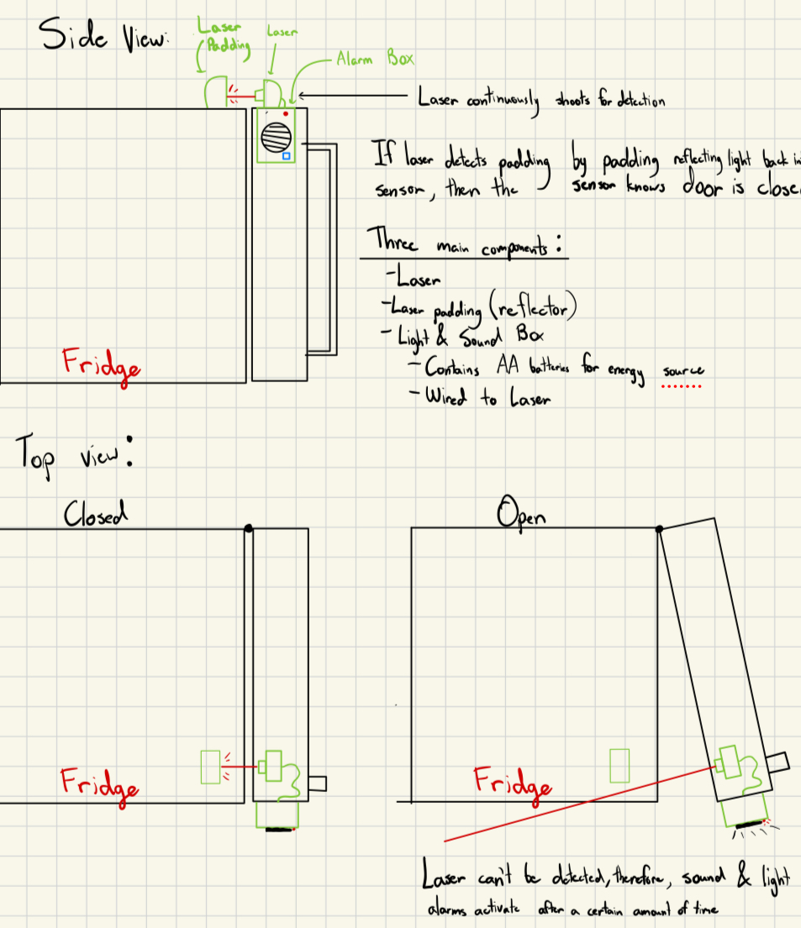

# 

## Concept 3

The following concept involves the integration of an angle sensor at the hinge of a refrigerator door, coupled with a PinPad and alarm system to address the need for enhanced security in frequently accessed refrigerators. The PinPad allows users to input a code, disarming the alarms triggered by the Angle Sensor, which monitors the door's open and closed status through a potentiometer. If the door remains open beyond a specified time, the alarms activate with sound and flashing lights. The key components include a motherboard, PinPad with LED, potentiometer, and a speaker box with AA batteries. The angle sensor utilizes the potentiometer to measure electrical resistance, translating it into voltage readings corresponding to the door's angle. Pros include non-obtrusive installation at the hinge and providing a precise, nuanced measurement of door openness. However, concerns revolve around affordability, potential variations in refrigerator hinge designs, and power consumption. Technical feasibility is largely favorable, but questions about handling and power requirements need addressing. The concept's novelty lies in using a potentiometer for refrigerator security, offering a more nuanced approach than existing binary systems.

# 

# 

## Concept 2, Final Concept Chosen, Initial Design

The final and chosen concept to start working for prototyping addresses the need for enhanced security and automatic door closure in frequently accessed refrigerators. The design incorporates a weighted mechanism, utilizing a spring and sensor, to ensure reliable closure of the refrigerator door. A pin pad lock provides a secure means of access, allowing users to input a passcode for unlocking and locking the door. Additionally, a sound and light alarm system activates if the refrigerator is opened without the pin pad, requiring manual closure and passcode entry to disarm the alarm. The weighted mechanism serves a dual purpose, automatically closing the door after a specified time and acting as a failsafe in case of alarm-triggered failures. Despite potential concerns regarding ease of manufacturing, this concept excels in providing heightened security, ease of use, and practicality, addressing the critical need to prevent unauthorized access to the refrigerator's contents while not completely having to worry about the door being left open. These factors set it apart from previous prototypes, offering a unique and effective solution to enhance the overall security of frequently accessed refrigerators.

# 

**Version 2 of the weighted door design**

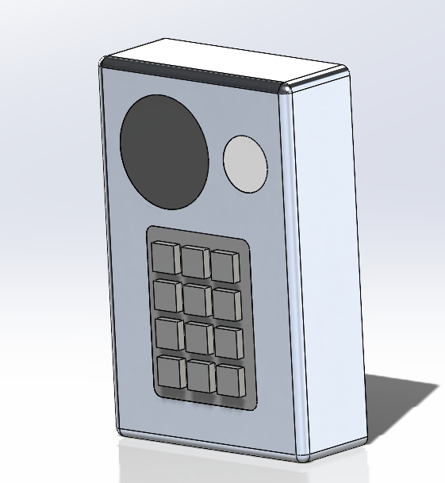

# References

# 

Links which we will base our weighted door design off of:

<https://www.youtube.com/watch?v=ueKuYcvDQHQ>

<https://www.youtube.com/watch?v=mXNhgCefKD8>

# Appendix

# 

## Interview With Steven Lucero

Q. What materials should be used for the housing and arm? Could they be the same material?

A. 6061 alloys for aluminum could work, though you have to be mindful of what machines you are using, for example, aluminum has to be machined. A variety of materials should probably be used. In the optimal parts of the design, sheetless cut stainless steel, 3D printed, and aluminum materials should be used.

Q. What parts could be 3D printed for rapid prototyping?

A. The case and arms could be done with PLA rapid prototyping while the interior would likely not be rapidly prototyped.

Q. Would it be possible to utilize the rotation about the arm joint with a rotational

potentiometer? How about using a slide inside the main housing?

A. It is possible to utilize the rotation about the arm joint with a rotational potentiometer or a rotary encoder. You could potentially make the wire longer so the joint can be more tolerant to movement. Furthermore, an idea to use in the design is a type of mechanical component that permits rotation with wires on either side called a slip ring.

Q. What are some potential mounting tactics we can use to ensure the components that need to stick together can stick?

A. Some mounting methods could be using adhesives, making the top wider for the surface area, epoxy weld possible if permanent, 3M, sticky form, or other products that could be searched. Furthermore, you might want to revisit the clip idea as a way to stick things together. Also, the idea of potentially sharing hardware with other fixtures should be thought of.

Q. What is the possibility of being able to adjust the height of the pinpad? Possible telescoping rod?

A. Being able to adjust the height of the pin pad is not really necessary.

Q. In order to make the arm able to contain a wire, how thick would the arm have to be?

A. You could keep the rotary on the top of the design potentially to contain the wire.

## 

## User Needs Flowchart

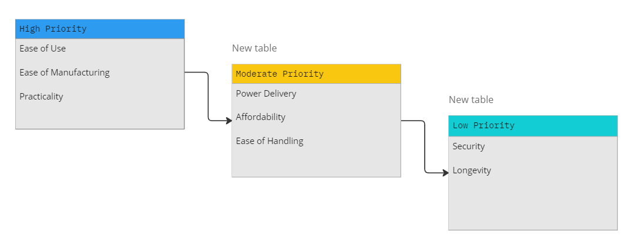

## 

## Engineering Design Specifications

| Metrics | Units | Corresponding User Needs | Range | Target Value | Direction of Improvement |
| --- | --- | --- | --- | --- | --- |
| Price | US Dollar | Affordability | $14-$984 | $300 | To be minimized |
| Battery Life | Weeks | Power Delivery | 1- | 8 | To be maximized |
| Passive Operation | Binary | Ease of Handling | Fully Active to Fully Passive | Mostly Passive | To be maximized |
| Number of Components | Numerical | Ease of Manufacturing | 10-100 | 20 | To be minimized |
| Established Technology | Binary | Practicality | Yes or No | Yes | N/A |
| Sensitivity | * | Security | 0-1 |  | To be maximized |
| Weight | kg | User Friendliness | 1 kg to 4 kg | 2 kg | To be minimized |

[1] TP: True Positive

[2] FN: False Negative